Fig-6 Flowchart shows management of extra-articular tibia deformity with knee arthritis.

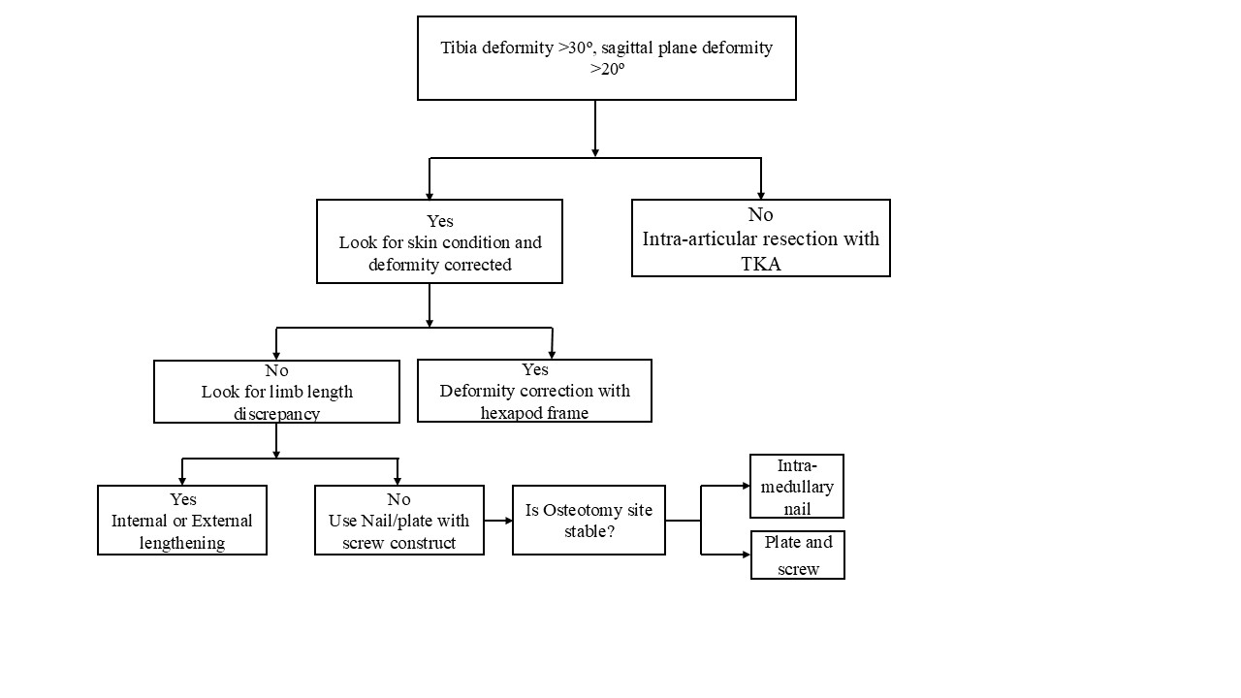

Table-2 shows review of literature for extra-articular tibia deformity managed with total knee arthroplasty.
S.No | Study | Cases | M:F | Mean Age(years) | Cause of Deformity | Surgery performed | HKA angle difference | Alignment | Implant used | Knee joint motion | Knee score | Follow-up(months)
1. | Xiao-Gang Z et al.⁵(2012) | 1.9( 5 femur and 4 tibia)  2.Tibia- (a)Proximal tibia(1)  (b) Tibia Metaphysis(3) | 1:3 | 53years | 1.Fracture(3)  2.Congenital dysplasia(1) | 1.Intra-articular correction(2) | 1.Pre-op HKA- 11.8ͦ(2-21ͦ)  2. Post-op HKA-1ͦ(0-4ͦ) | Mechanical alignment | 1.PS-Knee | 1.Pre-op-46.7ͦ(0-100ͦ)  2.Post-op-100.6ͦ(85-115ͦ) | 1.Pre- HSS Knee score-18.7(6-39)  2.Post-HSS Knee score-89.8(81-96) | 29 months
2. | Rhee et al⁶(2013) | 13(4 Tibia) | 4 females | 64.25years | Proximal tibia fracture malunion(4) | Intra-articular correction | 1.Pre-op HKA-7.2ͦ±11.8ͦ in varus( 25ͦ varus - 13ͦ valgus) | Mechanical Alignment(Navigation system) | PS-Knee | 1.Pre-op-83.5±19.8(50-125ͦ)  2.Post-op-118.5±10.5(100-135ͦ) | 1.Pre-op KSS-28.8$±5.7$  2.Post-op KSS-89.6$±4.6$ | 3.1years
3. | Rajgopal et al⁷(2013) | 36(20 Tibia) | 30:2 | 66.6 years ( 58-78 years) | 1.Malunion  2.Osteotomy  3.Metabolic disease  4.Developmental deformity | Intra-articular resection | 1.Pre-op HKA-14° ± 2° varus (26ͦ varus - 4° valgus)  2.Post-op HKA- 2° ± 0.6° varus (6° varus - 2° valgus) | Mechanical Alignment | 1.CR-Knee  2.PS-Knee  3.CCK  4.Minikeel tibia | 1.Pre-op-54ͦ(10-100ͦ)  2.Post-op-114ͦ(70-130ͦ) | 1.Pre-op KSS-37(10-80)  2.Post-op KSS-85(35-95)  3.Pre-op Function score-19(0-40)  4.Post-op Function score-69.5(0-90) | 85 months (42-120 months)
4. | Loures et al⁸(2018) | 25(Tibia-12 | 14:11 | 65.2years(48-79) | 1.Fractures(9)  2.Failed osteotomy(3) | Intra-articular resection | - | Mechanical alignment | PS-Knee | 1.Pre-op-92.6ͦ  2.Post-op-96.4ͦ | 1.Pre-KSS-27.1  2.Post-op KSS-68.7 | 8months(3-18)
5. | Matassi et al⁹(2018) | 18( 9 femur,7 tibia and 2 combined femur and tibia) | 9:9 | 63.7 ± 2.3years | 1. |  | 1.Pre-op HKA-7.8° ± 8.3°varus (range 15.6 varus to - 8.9 valgus)  2.Post-op HKA-0.9° ± 1.4°varus ( 2.2 varus to - 1.6 valgus)
5. | Jun-Wen Wang et al¹⁰(2021) | 21(15 included) | 11:4 | 64.6 years (54–83) | 1. Fractur Fmalunima(15)  (a) Upper third-(8)  2.Middle third-(4)  3.Lower third-(2)  4.Upper third and middle third(1) | Intra-articular correction | 1.Pre-op HKA-15.5° varus (r33° varus -18° valgus)  2.Post-op HKA-1.5° varus (6° varus - 2.8°valgus) | Mechanical alignment | 1.PS-Knee | 1.Pre-op-95° ( 75°–120°)  2.Post-op-118.3°(95°–130°) | 1.Pre-KSS-24.3 (15- 38)  2.Post-KSS-76.2 (54–90) | 84 months (24 -240)
6. | S.Agarwal et al¹¹(2021) | 6 | 6:0 | 66.5years | 1.Fracture(6)(Varus deformity-3 and Valgus deformity-3) | Intra-articular correction | 1.Pre-op HKA-12.6ͦ  2.Post-op HKA-4ͦ | Mechanical alignment(Computer navigation system) | PS-Knee | - | 1.Pre-op Oxford knee score - 19 (11 - 27)  2.Post-op score was 33.6 (24 - 44) | 4.5 years (2-15 years)
7. | Vedoya et al¹²(2021) | 28(Tibia(14) | 19:9 | 64.3 years (47–86 years) | 1.Fracture malunion-7  (a)Proximal tibia(3)  (b)Tibia shaft(4)  2.Post-osteotomy(6)  3.Fibula hemimelia(1) | Intra-articular correction | 1.Pre-op HKA-11.8ͦ  2.Post-op HKA-0.9ͦ | Mechanical alignment | PS-Knee | 1.Pre-op-83.7ͦ  2.Post-op-107.1ͦ | 1.Pre-op KSS-24.3(10-46)  2.Post-op KSS-86(69-90)  3.Pre-op Function score-34(12-53)  4.Post-op Function score-85.3(73-91) | 10.3 years (3–19 years)

Extra-articular Tibia Vara Deformity managed with Restricted Kinematic Alignment Total Knee Arthroplasty-A Case Report and Literature Review.
Explanations of questions as asked by reviewer’s-

All the additions in the main text has been highlighted in the main text.

Q.1 Lack of Valid Functional Outcome Assessment:
A.1 The functional outcome is assessed with KSS, KFS & OKS Score.
The pre-operative KSS improved from 35 to 87, KFS improved from 46 to 79 and OKS score improved from 17 to 44 at final follow-up. (Mentioned in the case presentation section)

Q.2 Insufficient Discussion of Risks and Alternative Treatment Options:
A.2 The treatment options are mentioned in the discussion section.
The management of extra-articular tibial deformity with knee arthritis has been summarized in fig-6.
Single-staged procedures, where deformity correction and total knee arthroplasty (TKA) are performed in a single sitting, offer several advantages. The chief advantage is patient undergoes only one surgical intervention, which leads to a single recovery period. As a result, patients are often able to resume their activities of daily living at an earlier stage compared to those who have staged procedures.
However, there are also disadvantages associated with single-staged procedures. These include an increased risk of blood loss during surgery, and there is a need to prevent cement spillage from the osteotomy site. Additionally, patients are at risk of non-union at the osteotomy site and there is a potential risk of pulmonary embolism.
Double-staged procedures, in contrast, involve two separate surgeries: one for the correction of the extra-articular deformity and another for the TKA. The advantages of this approach include greater flexibility in managing the extra-articular deformity and providing adequate time for the osteotomy site to achieve union. This staged approach also helps prevent complications related to cement extrusion from the osteotomy site and might obviate the ned for TKA for few years.On the other hand, double-staged procedures require the patient to undergo two separate surgeries, which is associated with a longer overall rehabilitation period. Consequently, there is a delay in the patient’s ability to resume their usual daily activities.¹⁶

Q.3 Overly Assertive Conclusions Based on a Single Case:
A.3 The conclusion is that the extra-articular deformity can be managed with robotic assisted TKA. In present case though we have used Restricted kinematic alignment but conclusion is robotics have made this complex scenario bit easy to manage.

Q.4 Significant Weakness in the Literature Review:
A.4 I have mentioned details about literature review and have included all the articles available, using different techniques for management of extra-articular tibia deformity.
We searched PubMed with the following keywords: tibia, extra-articular deformity, and total knee arthroplasty. We included the search results from 2012 to 2021, a total of 35 studies were available out of which 7 studies were included in the literature review. The inclusion criteria were extra-articular tibia deformity with knee arthritis managed with intra-articular resection and TKA. The exclusion criteria was extra-articular deformity affecting bone other than tibia, case reports and articles in the language other than english.
Q.5 Lack of Clarity on the Indications for Choosing RKA:
A.5 The present case was managed with robotic restricted kinematic alignment for extra-articular tibia deformity. But the message conveyed in the present report is effectiveness of robotics in these case scenarios.

