Mild Influenza-Associated Encephalitis with Predominant Neuropsychiatric Manifestations in a Child: a case report
Authors: Seyedeh Rojina Mortazavi ª, Dina Sadeghi ^{b}, Solmaz Aziz-ahari ^{c*}

Authors’ affiliations:
a. Student Research Committee, School of Medicine, Iran University of Medical Sciences, Iran.
b. Student Research Committee, School of Medicine, Isfahan University of Medical Sciences, Iran
c. Department of pediatric neurology, School of Medicine, Iran University of Medical Sciences,
Tehran, Iran

*Corresponding author:
Email: solmaz.azizahari@gmail.com

Abstract
Influenza-associated encephalitis (IAE) is a rare but serious complication of influenza infection, predominantly affecting children. While most reported cases present with moderate to severe neurological symptoms, mild and self-limiting forms remain underrecognized. We report the case of a previously healthy 9-year-old boy who presented with fever, lethargy, behavioral changes, and two episodes of nocturnal complex behavior concerning for seizures during the course of an influenza-like illness. Laboratory evaluations were notable for leukopenia and elevated D-dimer levels. Neuroimaging revealed a medial right temporal arachnoid cyst, and cerebrospinal fluid (CSF) analysis showed mild pleocytosis with positive Influenza A PCR. Electroencephalography was normal. The patient was managed with intravenous antibiotics, antiviral therapy, and supportive care. His symptoms resolved rapidly without neurological sequelae, and he made a complete recovery. This case highlights that influenza-associated encephalitis can present with mild, transient neuropsychiatric symptoms. It demonstrates that a positive respiratory influenza test does not preclude central nervous system involvement, underscoring the importance of cerebrospinal fluid analysis for diagnosis and to avoid unnecessary interventions.

Keywords: Influenza A, encephalitis, neuropsychiatric symptoms

Introduction
Influenza-associated encephalitis (IAE) is a rare but clinically relevant neurological complication of Influenza infection, occurring predominantly in the pediatric population. The clinical spectrum of IAE is highly heterogeneous, ranging from severe encephalopathy with significant morbidity to mild, transient forms with subtle neurological or neuropsychiatric manifestations (1,2). While severe phenotypes are well described in the literature, milder presentations are likely underrecognized and underreported, particularly in cases with normal neuroimaging and electroencephalography (1,3). As a result, central nervous system (CNS) involvement may be overlooked, and opportunities for targeted diagnostic evaluation may be missed.
Children with mild IAE may present primarily with behavioral changes, altered mental status, or sleep-related phenomena, which can complicate differentiation from seizure disorders, parasomnias, or acute states of confusion (2,3). Recognition of these subtle presentations is essential to ensure appropriate diagnostic reasoning and management. Here, we report a mild and self-limiting case of IAE in a previously healthy child, presenting predominantly with transient neuropsychiatric manifestations. This case underscores the importance of cerebrospinal fluid analysis in confirming central nervous system involvement, even when clinical features are subtle and routine investigations are non-diagnostic.
This report highlights three underrecognized aspects of pediatric IAE. First, our case is among the few with a positive CSF Influenza A PCR in the setting of completely normal imaging and no electrophysiological abnormalities. Second, the main clinical features were neuropsychiatric, lacking typical seizures or focal deficits.The particular finding of nocturnal complex behaviors mimicking parasomnias or focal seizures has not been previously emphasized in IAE literature. Third, the presence of minimal Cerebrospinal Fluid (CSF) pleocytosis, a positive CSF PCR, and rapid full recovery without immunotherapy points to a mild, often overlooked end of the IAE spectrum. This supports a lower threshold for lumbar puncture in children with influenza who develop any neuropsychiatric symptom, even when mild and transient (1,4).

Case Presentation
A previously healthy 9-year-old boy presented with a four-day history of fever, fatigue and lethargy. During the illness course, the child developed acute behavioral withdrawal, characterized by reduced social interaction and attentiveness. On illness day three, the patient experienced two nocturnal episodes characterized by abrupt arousal from sleep with disorganized, semi-purposeful behavior, including verbal expression of intent to engage in playing football during inappropraite hours. Each episode lasted several minutes, and one episode was associated with urinary incontinence, raising concern for possible seizure activity.
Initial laboratory evaluation revealed leukopenia (white blood cell count: 2.2 × 10³/µL). Following initiation of empiric antimicrobial therapy and oseltamivir, the patient was transferred to a tertiary center for further evaluation. On admission, the patient was alert but behaviorally withdrawn. Vital signs were stable, and neurological examination revealed no focal deficits. Repeat laboratory studies confirmed persistent leukopenia (1.8 × 10³/µL) and an elevated D-dimer level (736 ng/mL). A nasopharyngeal polymerase chain reaction (PCR) was positive for Influenza A. Empiric therapy with intravenous cefepime and acyclovir was initiated to cover possible bacterial and viral central nervous system infections. Electroencephalography was normal, and brain magnetic resonance imaging (MRI) revealed no acute parenchymal abnormalities, aside from an incidental right medial temporal arachnoid cyst (Figure 1). A lumbar puncture was subsequently performed. CSF analysis demonstrated mild pleocytosis (5 cells/µL) with normal glucose and protein concentrations. CSF PCR was negative for herpes simplex virus but positive for Influenza A, confirming central nervous system involvement (Table 1).
Following confirmation of the diagnosis, acyclovir was discontinued, and a complete course of oseltamivir was administered. The patient’s behavioral and neuropsychiatric symptoms resolved rapidly over the subsequent two days. The patient was discharged in good clinical condition on illness day 11. At one-week follow-up, the child remained asymptomatic, with no neurological sequelae.

Parameter | Measured value
Appearance | Clear
Color | Colorless
White Blood Cell (WBC) | 5 cells/μL
Red Blood Cell (RBC) | 25 cells/μL
Glucose | 63 mg/dL
Protein | 25 mg/dL
Lactate Dehydrogenase (LDH) | 40 unit/L
HSV PCR | Negative
Influenza PCR | Positive for type A
Table 1. CSF findings in the reported patient

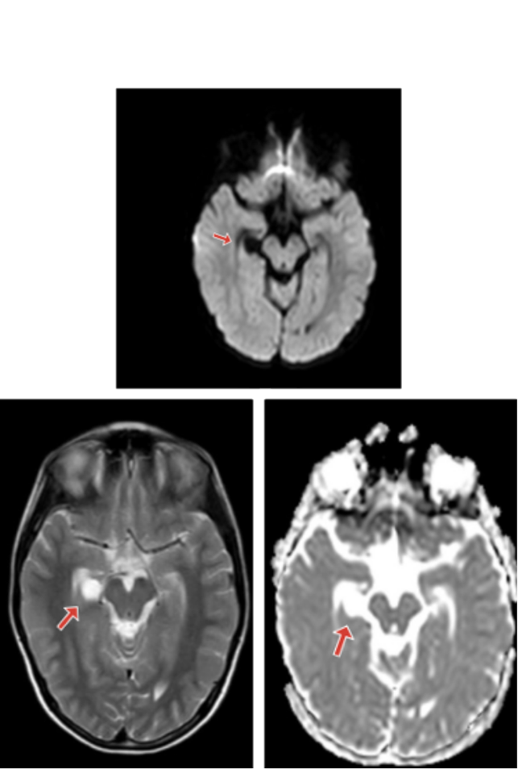

Figure 1. Brain MRI without contrast demonstrating a well-defined lesion with high signal intensity on T2-weighted images and low signal intensity on T1-weighted images in the medial right temporal lobe, adjacent to the midbrain, causing mild compression of the right hippocampus, consistent with an incidental arachnoid cyst. Importantly, this finding was entirely incidental; it bore no relationship to the patient's acute neuropsychiatric symptoms, did not explain the positive CSF Influenza A PCR, and played no role in the diagnosis or clinical course of IAE.

Discussion

Influenza-associated encephalitis (IAE) represents a rare but clinically important neurological complication of influenza infection in children, characterized by a broad and heterogeneous clinical spectrum. While severe forms—such as acute necrotizing encephalopathy—are well recognized, milder presentations remain less frequently reported, particularly when neurological findings are subtle and investigations are non-diagnostic (1,2).
The present case exemplifies a self-limiting, mild form of IAE in which the predominant manifestations were acute behavioral withdrawal and nocturnal complex behaviors. These features posed a diagnostic challenge, as the nocturnal episodes could plausibly be interpreted as focal seizures, parasomnias, or acute confusional states. Such clinical ambiguity is well documented in the literature, where behavioral and sleep-related disturbances in mild IAE are reported to mimic non-encephalitic conditions, often delaying recognition of CNS involvement (2,3).
Although the precise pathophysiological mechanisms underlying IAE are not completely understood, accumulating evidence supports a predominant role for immune-mediated and cytokine-driven neuroinflammatory processes, rather than direct viral neuroinvasion in all cases (2,3). Transient dysfunction of limbic and diencephalic networks, which regulate behavior, arousal, and sleep, may account for the neuropsychiatric and sleep-related manifestations observed in mild presentations such as this case.
A central diagnostic insight from this report is that a positive respiratory influenza test does not exclude CNS involvement. In our patient, both neuroimaging and electroencephalography were normal, and the only radiological finding was an incidental temporal arachnoid cyst, which was not considered causative given the acute temporal relationship to influenza infection and complete clinical recovery. Importantly, CSF analysis revealed mild pleocytosis and a positive Influenza A PCR, establishing the diagnosis of encephalitis. This underscores the diagnostic value of lumbar puncture in children with influenza who develop neurological or behavioral symptoms, even when such symptoms are transient or mild. Studies have emphasized that CSF PCR for influenza, though not uniformly positive, can provide definitive evidence of CNS involvement in select cases (1,4).
Autoimmune encephalitis (AE) was considered in the differential diagnosis given the acute neuropsychiatric presentation. However, the absence of characteristic features such as new-onset seizures, movement disorders, autonomic instability, EEG abnormalities (no slowing or epileptiform activity), along with the positive CSF Influenza A PCR, complete resolution without immunotherapy, and no relapse during follow-up, made autoimmune etiologies unlikely (5,6). No specific autoantibody panel was pursued because the clinical picture and temporal association with influenza infection sufficiently explained the presentation. Furthermore, the mild self-limited course did not justify additional testing. We acknowledge that the absence of autoantibody data is a limitation of this report; however, given the low pretest probability and the patient's rapid recovery, autoantibody testing was not clinically indicated at our center, where such panels are not routinely performed.
Recognition of mild IAE has relevant clinical implications. Early confirmation of CNS involvement may prevent unnecessary prolonged antimicrobial therapy, support timely antiviral treatment, and allow for appropriate prognostic counseling and follow-up (1,3). The rapid and complete recovery observed in this patient aligns with outcomes reported in other mild cases and reinforces the concept that IAE should be viewed as a continuum of disease severity, rather than a uniformly severe entity. The contrasting outcomes reported in severe pediatric IAE series, with mortality rates approaching 20% and significant neurological sequelae in survivors, further highlight the importance of identifying and characterizing milder phenotypes to fully understand the spectrum of influenza-related CNS complications (7).
This case illustrates that IAE in children may present as a mild and transient neuropsychiatric syndrome, with behavioral and sleep-related disturbances as the predominant clinical features. Normal neuroimaging and electroencephalography do not exclude CNS involvement in this context. We emphasize that the emergence of neurological or behavioral symptoms in pediatric patients with influenza should prompt consideration of CSF analysis, even when respiratory testing is positive and symptoms are subtle. Increased awareness of these mild presentations may facilitate accurate diagnosis, rational management, and improved recognition of the full clinical spectrum of IAE.

Conflicts of interest

The authors declare that there is no conflict of interest regarding the publication of this article.

Ethics Statement

Written informed consent was obtained from the patient’s legal guardians for publication of this case report and any accompanying images.

Funding statement
No funding was received for this study.

Acknowledgments

The authors would like to thank the Firoozabadi Clinical Research Development Unit (FACRDU) for its support and assistance in conducting this study.

References
1. Savagner J, Trémeaux P, Baudou E, Mansuy JM, Cheuret E. Neurological involvement related to the influenza virus in children: A 5-year single-centre retrospective study. Eur J Paediatr Neurol. 2024 Jul;51:100–9.
2. Wang GF, Li W, Li K. Acute encephalopathy and encephalitis caused by influenza virus infection. Current opinion in neurology. 2010;23(3):305–11.
3. Paksu MS, Aslan K, Kendirli T, Akyildiz BN, Yener N, Yildizdas RD, et al. Neuroinfluenza: evaluation of seasonal influenza associated severe neurological complications in children (a multicenter study). Childs Nerv Syst. 2018;34:335–47.
4. Jantarabenjakul W, Paprad T, Sophonphan J, Pluemjit P, Wongsrisang L, Wongsrisang J, et al. Neurological complications associated with influenza in hospitalized children. Influenza Other Respir Viruses [Internet]. 2023;17(e13075). Available from: https://pubmed.ncbi.nlm.nih.gov/36514185/
5. Moreno-Avellán A, Juarez-Jaramillo A, Fernandez Gonzalez-Aragon M, Quiñones-Pesqueira G, Pineda-Centeno L, Espinola-Nadurille M, et al. The Clinical Significance of Abnormal Electroencephalography (EEG) Patterns in Patients with Neuropsychiatric Disorders Due to Anti-NMDA Receptor Encephalitis: A Comparative Study. Diagnostics (Basel). 2025 Apr 29;15(9):1131.
6. Kanji F. Autoimmune Encephalitis: Evolving Clinical Spectrum and Updated Management. Paediatric Nephrology Journal of Bangladesh. 2024 Jun;9(1).
7. Nguyen SD, Ngo THT, Nguyen TVH, Do TH. Severe Neurological Complications With Influenza in Vietnamese Children. Influenza Other Respir Viruses. 2024 Nov;18(11):e70035.

